Secondary V English Language Arts D’Arcy McGee H.S.

Literary Codes and Conventions

The following is a list of terms that describe elements of writing and writing devices/techniques (codes and conventions) that are useful when reading, analyzing and writing fiction and non-fiction.
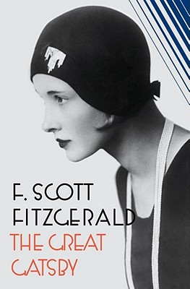

1. Allegory: It is a story in prose or verse which carries another meaning along with the surface story. The characters usually represent abstract ideas, moral qualities, or other abstractions.
A very good example of allegory is George Orwell’s novel Animal Farm, where farm animals revolt against the farmer. On a literal level it is a simple story about a farm. On a secondary level, it is an allegory of the Russian Revolution with each animal representing an historical person or abstract quality related to the Revolution.

2. Alliteration*: The repetition of consonant sounds, especially at the beginning of words usually close together. This technique is used to draw attention to a particular part of a poem or narrative. It also serves to add continuity or fluidity to verse or narrative writing.
Tongue-twisters are good examples of alliteration: ‘Rubber baby buggy bumpers’ or ‘She sells seashells by the seashore.’ Alliteration is often used in newspaper or magazine headlines.

3. Allusion*: An informal reference in literature to something familiar (a person, place, event, or another passage of literature): something or someone that the writer hopes the reader will recognize without needing an explanation. Allusions can originate in mythology, biblical references, historical events, legends, geography, earlier literary works or other media. Authors often use allusion to establish a tone, create an implied association, contrast two objects or people, make an unusual juxtaposition of references, or bring the reader into a world of experience outside the limitations of the story itself.

4. Ambiguity: When the meaning or outcome of a text is open to interpretation (as in an open ending). Intentional ambiguity in literature can be a powerful device, leaving something deliberately open in order to offer multiple possible meanings.

5. Anecdote*: A short narrative account of an amusing, unusual, revealing, or interesting event. A good anecdote has a single, definite point, and the setting, dialogue, and characters are usually subordinate to the point of the story. Usually, the anecdote does not exist alone, but it is combined with other material such as articles, expository essays or arguments. Writers may use anecdotes to clarify abstract points, to humanize individuals, or to create a memorable image in the reader's mind.

6. Analogy*: The use of a more familiar or simpler thing or event to describe or explain something that is complex or confusing: ‘Think of the human brain as a calculator’.

7. Anti-hero: A protagonist who is a non-hero or the antithesis (direct opposite) of a traditional hero. While the traditional hero may be dashing, strong, brave, resourceful, or handsome, the anti-hero may be incompetent, unlucky, clumsy, dumb, ugly, or clownish.

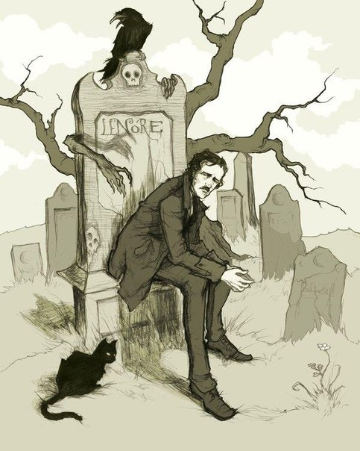Edgar Allan Poe

8. Antagonist: A character that is often seen to be creating conflict in a story. He or she stands opposite to the protagonist but is not always evil (Banquo is the antagonist in Macbeth yet Banquo is not evil).
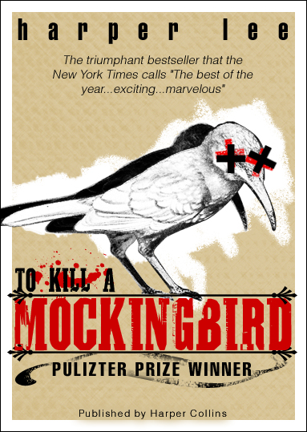

9. Archetype: In literature, an archetype is a typical character, an action or a situation that seems to represent such universal patterns of human nature.
An archetype, also known as universal symbol, may be a character, a theme, a symbol or even a setting. Many literary critics are of the opinion that archetypes, which have a common and recurring representation in a particular human culture or entire human race, shape the structure and function of a literary work.
Carl Jung, Swiss psychologist, argued that the root of an archetype is in the “collective unconscious” of mankind. The phrase “collective unconscious” refers to experiences shared by a race or culture. This includes love, religion, death, birth, life, struggle, survival etc. These experiences exist in the subconscious of every individual and are recreated in literature and art.
Below is the analysis of common archetypes that exist in literature.

Archetypes in Characters

1.The Hero: He or she is a character who predominantly exhibits goodness and struggles against evil in order to restore harmony and justice to society e.g. Beowulf, Hercules, D’artagnan from “The Three Musketeers” etc.

2.The Mother Figure: Such a character may be represented as Fairy Mother who guides and directs a child, Mother Earth who contacts people and offers spiritual and emotional nourishment, and the stepmother who treats their stepchildren roughly.
Some examples in literature are Glinda from The Wizard of Oz and Gladriel from The Lord of the Rings. In fairy tales examples include the stepmother in “Cinderella”, fairy godmothers, Mother Goose, and Little Red Riding Hood’s grandmother. In mythology some figures include Persephone, Demeter, Hecate, Gorgon, and Medusa

3.The Innocent Youth: He or she is inexperienced with many weaknesses and seeks safety with others but others like him/her because of the trust he or she shows in other people. Usually, the experience of coming of age comes in the later parts of the narratives such as Pip in Dickens’ Great Expectations, Ralph in Lord of the Flies, and Scout and Gem in To Kill a Mockingbird, etc.

4.The Mentor: His or her task is to protect the main character. It is through the wise advice and training of a mentor that the main character achieves success in the world e.g. Gandalf in “The Lords of Rings, and the Nurse in Romeo and Juliet, etc.

5.Doppelganger: It is a duplicate or shadow of a character that represents the evil side of his personality. Examples are in popular literary works such as Shakespeare’s Hamlet, Mary Shelley’s Frankenstein, Stevenson’s Dr. Jekyll and Mr. Hyde , etc.

6.The Scapegoat: A character that takes the blame for everything bad that happens, like Snowball in Orwell’s Animal Farm or Tom Robinson in To Kill a Mockingbird.

7.The Villain: A character whose main function is to go to any extent to oppose the hero or whom the hero must annihilate in order to bring justice e.g. Shere Khan from Kipling’s The Jungle Book stories, Long John Silver from Stevenson’s Treasure Island, etc

Archetypes in Situations

8.The Journey: The main character takes a journey that may be physical or emotional in order to understand his or her personality and the nature of the world. For example, Tolkien’s The Hobbit, Salinger’s The Catcher in the Rye, Swift’s Gulliver’s Travels, etc.

9.The Initiation: The main character undergoes experiences that lead him towards maturity. We find such archetypes in novels like Montgomery’s Anne of Green Gables, Satrapi’s Persepolis and Lee’s To Kill a Mockingbird.

10.Good Versus Evil: It represents the clash of forces that represent goodness with those that represent evil. Examples of this archetype are in famous literary works like Shakespeare’s Macbeth, Conrad’s Heart of Darkness, Wells’ The Invisible Man, etc.

11.The Fall: The main character falls from grace in consequence of his or her own action e.g. Oedipus from Sophocles “Oedipus Rex”, Lear from Shakespeare’s “King Lear” etc.

Function of Archetype

The use of archetypical characters and situations gives a literary work a universal acceptance, as readers identify the characters and situations in their social and cultural context. By using common archetype, the writers attempt to impart realism to their works, as the situations and characters are drawn from the experiences of the world.
10. Bias (stance)*: In non-fiction pieces, when the writer’s opinion comes through and is detectable by the careful reader. In an objective piece bias is supposed to be avoided, though it is obviously necessary in an editorial or persuasive piece.

11. CARPE DIEM: Literally, the phrase is Latin for "seize the day”. The term refers to a common moral or theme that the reader should make the most out of life and should enjoy it before it ends. YOLO

12. Character types: The four main types of characters are differentiated by how much we know of them and whether or not they change:

a) Flat: A character about whom we know only one or two things. (Two- dimensional)
b) Round: A character about whom we know many things. (Three-dimensional)
c) Static: A character, either flat or round, that does not change at all throughout the story.
d) Dynamic: A character, either flat or round, that does change at some point in the story.

13. CHARACTERIZATION: The process by which a character is described and developed as a story. There are two types:

a) Direct Characterization: The character is described by the narrator or another character as being a certain way. For example, ‘Jack was tough-minded with a strong-jaw to match.’
b) Indirect Characterization: We learn something about the character through the character’s actions, words or how they look. For example, ‘Everyday Jack climbed the steps like he was scaling Mt. Everest,’ or ‘Jack’s pants never seemed to be clean’.

14. Circular structure*: A manner of organizing a piece of writing so that its sense of completeness or closure originates in the way it returns to subject-matter, wording, or phrasing found at its beginning. An example of circular structure is "The Secret Life of Walter Mitty," which ends with an ellipsis (…) identical to the opening sequence, indicating that the middle-aged protagonist is engaging in yet another escapist fantasy. Leigh Hunt's poem "Jenny Kissed Me" is an example of a circularly-structured poem, since it ends with the same words that open it. Langdon Smith's poem "Evolution" is circular in its concluding repetition of the opening phrase, "When you were a tadpole, and I was a fish."

15. Cliche: A cliché is a phrase or metaphor that was once fresh and original, but has become unoriginal and uninspired through overuse. Clichés are considered bad writing.

16. Colloquialism*: A word or phrase used every day in plain and relaxed speech, but rarely found in formal writing: ain‘t, gonna, wanna, kinda, atcha, etc. It is often used for realism.

17. Coming-of-age story (also known as bildungsroman or a ‘rites of passage’ story):
A type of novel where the protagonist is initiated into adulthood through knowledge, experience, or both, often by a process of disillusionment. Understanding comes after the dropping of preconceptions, a destruction of a false sense of security, or in some way the loss of innocence.

Some of the shifts that take place are these:
◆ ignorance to knowledge
◆ innocence to experience
◆ false view of world to correct view
◆ idealism to realism, and
◆ immature responses to mature responses.

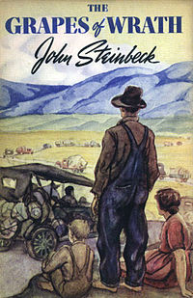
18. Conflict: Conflict is the obstacle a main character faces in a story. There are two main types:

a) External: Character vs. one or more of the following: nature (farmer vs. tornado), another character (police officer vs. bank robber), society (student vs. friends’ influence/peer pressure), the supernatural (Van Helsing vs. Dracula), technology (grandmother vs. new computer, Mr. Burke vs. killer robot), fate (disaster survivor vs. insurmountable odds), etc.
b) Internal: Character vs. self. (a murderer vs. his/her conscience, a soldier vs. duty)

19. Connotation*: This is the perceived meaning of something. It may be very different from the denotation, or literal dictionary meaning of it. A word can have a positive or negative connotation. For example, the denotation of worm is a long slender animal that burrows in the earth. This word has a negative connotation since we often think of worms as slimy and disgusting. We also refer to someone who is not honest or straightforward as a worm.

20. Convention*: A common feature that has become traditional or expected within a specific genre (category) of literature or film. A convention for romance authors is that the hero and heroine must live happily ever after.

21. Denotation*: This is the dictionary definition of a word.
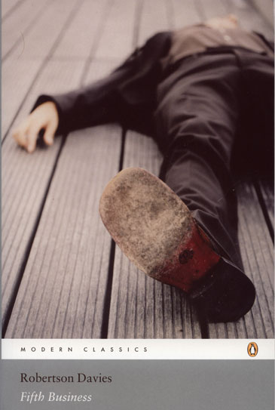Fifth Business by Robertson Davies

22. Diction*: An author's choice of words (word choice). Since words have specific meanings and impacts, and since one's choice of words can affect feelings, a writer's choice of words has great significance in a literary work. The writer chooses his words carefully. Discussing his novel A Farewell to Arms during an interview, Ernest Hemingway stated that he had to rewrite the ending thirty-nine times. When asked what was the most difficult thing about finishing the novel, Hemingway answered, "Getting the words right."

23. Dystopian novel: In a dystopian novel everything has gone wrong (often in the attempt to create a perfect society) and the result is a worst-case scenario where things are as bad as they can be. (It is the opposite of a utopian novel.) For example, the novels Nineteen Eighty-Four (1949) by George Orwell and Brave New World (1931) by Aldous Huxley explore dystopian societies.
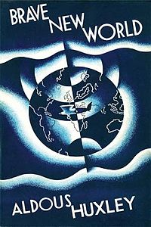

24. Epiphany: In literary terms, an epiphany is that moment in the story where a character achieves realization, awareness or a feeling of knowledge after which events are seen through the prism of this new light in the story.
James Joyce, the great Irish writer, used this term in his writings to indicate a sudden eye-opener regarding the nature of a person or situation. He said that it is the moment in which “the soul of the commonest object … seems to us radiant, and may be manifested through any chance, word or gesture.” He means to say that even insignificant things in our life can suddenly inspire in us an awareness that can change our lives for good.
Shakespeare also makes use of an epiphany in his play Hamlet when Hamlet, the hero, is on a ship sailing to England. Till then, he was over-burdened with thinking and planning a flawless revenge on his father’s murderer, Claudius. Suddenly there is a flash of realization and he says: “there is a divinity that shapes our ends, rough-hew them how we may.” He realizes that there is no wisdom for him to try to inflict the perfect revenge on Claudius — he must take hold of the moment, go with the current and dispose of his uncle, the usurper.

25. Euphemism: The use of polite language to describe something that is not nice or desirable. For example, one might say, ‘he passed gas’ or ‘he is flatulent’ instead of ‘he farted.’

26. Flashback and Flash-forward: An element of plot whereby an author reveals plotline that occurs before or after the present. For example, the T.V. series Lost made use of both of these plot techniques. Although the “present” in the show involved characters surviving on an island, the show’s characters were developed by flashing back to their lives before crashing on the island and by flashing forward to after they have been rescued.

27. Foil: The word foil comes from the old practice of backing gems with foil in order to make them shine more brightly. In fiction, a foil is a character who contrasts with another character (usually the protagonist) in order to highlight particular qualities of the other character. A foil usually either differs drastically or is extremely similar but with a key difference setting them apart.
In Shakespeare's play Julius Caesar, the character Brutus has foils in the two characters Cassius and Mark Anton. In the Harry Potter series, Draco Malfoy arguably is a foil to the Harry Potter character; Professor Snape enables both characters "to experience the essential adventures of self-determination" but they make different choices.

28. Foreshadowing: An author’s use of hints or clues to suggest events that will occur later in the story. Not all foreshadowing is obvious. Frequently, future events are merely hinted at through setting, dialogue, description, or the attitudes and reactions of the characters.
Foreshadowing frequently serves two purposes. It builds suspense by raising questions that encourage the reader to go on and find out more about the event that is being foreshadowed. Foreshadowing is also a means of making a narrative more believable by partially preparing the reader for events which are to follow.
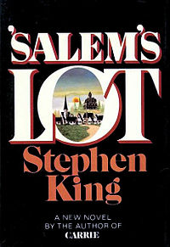

29. Genre: A type of literature. We say a poem, novel, story, or other literary work belongs to a particular genre if it shares at least a few conventions (standard technique or often-used devices), or standard characteristics, with other works in that genre.
For example, works in the horror genre often feature supernatural elements, attempts to horrify the reader, and dark, foreboding settings. Poe's short story "The Fall of the House of Usher" belongs to the horror genre because it takes place in a gloomy mansion that seems to exert supernatural control over a man who lives in it.
An understanding of genre is useful because it helps us to see how an author uses, plays with, or advances the standard practices that other authors have developed. (http://www.uncp.edu/home/canada/work/allam/general/glossary )

30. Hyperbole (overstatement): An exaggerated statement used to heighten effect. It is not used to mislead the reader, but to emphasize a point or to startle the reader. For example, ‘I’ve told you a million times to do your homework!’ or ‘I haven’t seen you in ages!’

31. Imagery*: Imagery describes an author’s use of various techniques (metaphor, simile, personification, allusion, literal description, symbolism, etc.) to create an ‘image’ in the reader’s mind by playing on one or all of our senses (using words to paint pictures). Imagery is not limited to visual imagery; it also includes auditory (sound), tactile (touch), thermal (heat and cold), olfactory (smell), gustatory (taste), and kinaesthetic sensation (movement).
He sat prostrate before his killer, blood streaming from the gash in his throat. Reaching the floor, his life essence lazily painted a red ribbon upon the cold marble of the foyer.

Imagery is sensory: visual, auditory (hearing), tactile (touch) or olfactory (smell).

32. In media res (Latin: "In the middle[s] of things"): This is a device used to start a story quickly at a point when the action or the plot is already. Later on in the story, the reader will be told what events took place earlier and how the story got to the point where the book began. Usually in medias res is a technique used to heighten dramatic tension or to create a sense of mystery.

33. Irony*: Language in which the attitudes or values implied are different from those expressed.
Basic irony is when something happens that was not expected to happen. There are several types:

a) Situational Irony: When something occurs that we would not expect to occur. For example, Ted is afraid of bears so he doesn’t like to go camping. His wife loves camping so, grudgingly, he agrees to go on a trip, but only in Texas where there are no bears. Unfortunately, the very day he arrives, a ferocious Grizzly bear escapes from the Austin City Zoo and mauls Ted as he sleeps unsuspectingly in his tent.

b) Dramatic Irony: When the reader knows something that one (or more) character does not. This means that the audience has knowledge that gives additional meaning to a character's words. Depending on what type of character is left in the dark, the reader may feel pity, happiness, or anxiety as a result of what may be in store for them. An example of dramatic irony is when King Oedipus, who has unknowingly killed his father, says that he will banish his father's killer when he finds him.

c) Verbal Irony:
☞ Understatement (Litotes): Purposely downplaying something to create the opposite effect of drawing attention to it. For example, a plane is crashing and a passenger says, “Well, this sucks.”
☞ Overstatement (Hyperbole): Purposely exaggerating something to the point of disbelief in order to make someone believe it. For example, ‘I’ve got, like, a billion of those.’
☞ Sarcasm: Purposely saying the opposite of what is meant in order to convey a message. It is usually done in a spiteful way though it can also be used in a humorous way. For example, ‘C’mon, man, everyone knows KFC is the healthiest food available.’ The speaker means the opposite of what they are saying.

34. Juxtaposition*: Juxtaposition is a literary device wherein the author places a person, concept, place, idea or theme parallel to another. The purpose of juxtaposing two directly or indirectly related entities close together in literature is to highlight the contrast between the two and compare them. This literary device is usually used for etching out a character in detail, creating suspense or lending a rhetorical effect (juxtaposed characters are also called foils). .
In his epic poem, Paradise Lost, John Milton uses juxtaposition to draw a parallel between the two protagonists, Satan and God, who he discusses by placing their traits in comparison with one another to highlight their differences.
From: http://literary-devices.com/content/juxtaposition

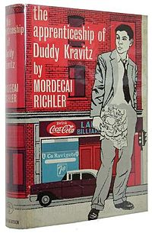

35. Metaphor*: A figure of speech in which two dissimilar objects are compared. Metaphors are useful when describing things. For example, “The wrestler John was supposed to fight was a monster.” Another example is “Love is a many-splendored thing”. If a writer keeps coming back to a metaphor and using it in various ways as a story progresses, that metaphor becomes an extended metaphor. (At the end of his match John looked like he’d been mangled by a sasquatch.) An allegory can be considered a very extended metaphor.

36. Mood*: (1) In literature, mood is a feeling, emotional state, or disposition of mind -- especially the predominating atmosphere of a literary work. Most pieces of literature have a prevailing mood, but shifts in this main mood may function as a counterpoint (something that adds contrast) provide comic relief, or echo the changing events in the plot. The term mood is often used synonymously with atmosphere and ambiance. Students and critics who wish to discuss mood in their essays should be able to point to specific diction, description, setting, and characterization to illustrate what sets the mood.
Often writers and filmmakers like to contrast moods to emphasize and achieve a certain reaction. Scenes of levity and happiness are often juxtaposed with their opposite moods. For instance, in The Great Gatsby a party scene comes to a crashing halt when Tom Buchanan breaks his mistress’s nose.

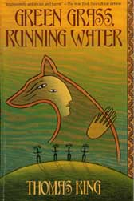

37. Motif*: A motif is a recurring element within a particular piece of writing, such as phrases, descriptions, or patterns of imagery. Through its repetition, a motif can help emphasize and/or develop other narrative (or literary) aspects, such as theme or mood.
A motif can be created through imagery, structural components, language, and other narrative elements. An example from modern American literature is the green light found in the novel The Great Gatsby (1925) by F. Scott Fitzgerald.
Narratives may include multiple and different types of motifs. Shakespeare's play Macbeth (1603) uses a variety of codes and conventions to create many different motifs. Images referring to blood and water are continually repeated. The phrase "fair is foul, and foul is fair" is heard at many points in the play, a combination that mixes the concepts of good and evil. The play also features the central motif of the washing of hands, one that combines both verbal images and the movement of the actors.

38. NARRATION, NARRATIVE: Narration is the act of telling a sequence of events, often in chronological order. A narrative refers to any story, whether in prose or verse, involving events, characters, and what the characters say and do. A narrative is another term for the story.

39. Onomatopoeia*: The use of sounds that are similar to the noise they represent for a realistic or artistic effect. For instance, hiss, bang, buzz, click, rattle, and grunt make sounds akin to the noise they represent.
A higher level of onomatopoeia is the use of imitative sounds to create an auditory effect. For instance, Tennyson writes in “The Princess” about "The moan of doves in immemorial elms, / And murmuring of innumerable bees." All the /m/ and /z/ sounds ultimately create that whispering, murmuring effect Tennyson describes.

40. Oxymoron*: Using contradiction in a manner that oddly makes sense on a deeper level. Simple or joking examples include such oxymora as jumbo shrimp, sophisticated rednecks, military intelligence, living dead and controlled chaos. The richest literary oxymora seem to reveal a deeper truth through their contradictions. These oxymora are sometimes called paradoxes. For instance, "Without laws, we can have no freedom." Shakespeare's Julius Caesar also makes use of a famous oxymoron: "Cowards die many times before their deaths" (2.2.32).
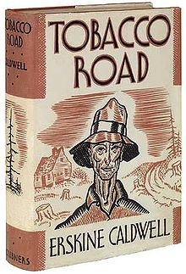

41. Paradox*: A statement which appears to be self-contradictory yet involves an element of truth. Paradox uses contradiction in a manner that oddly makes sense on a deeper level. For example, It was both night and day in that frosty part of the world or The child is the father of a man. In Shakespeare’s Hamlet, Polonius observes, “Though this be madness, yet there is method in't." Another famous paradox is Chesterton‘s observation that "Spies do not look like spies." Paradox exists in a simpler form as oxymoron.

42. Parody*: A parody imitates the serious manner and characteristic features of a particular literary work in order to make fun of those same features. The humorist achieves parody by exaggerating certain traits common to the work, much as a caricaturist creates a humorous depiction of a person by magnifying and calling attention to the person's most noticeable features. The term parody is often used synonymously with the more general term spoof, which makes fun of the general traits of a genre rather than one particular work or author. Often the subject-matter of a parody is comically inappropriate, such as using the elaborate, formal diction of an epic to describe something trivial like washing socks or cleaning a dusty attic.

43. Personification*: When abstractions, animals, ideas, and inanimate objects are given human traits, abilities, or reactions. Inanimate objects (tables, laptops, bedposts) and abstract ideas (love, hate, integrity) are treated as if they were human. For example, ‘The tree swayed in the breeze, its arms waving to me as I passed’ or ‘Love stomped all over my heart tonight’.

44. Plot: The sequence of events in a narrative (a story). Plot typically consists of four main elements. Depending on the genre of the story, certain elements may be more or less evident. In some cases, elements may be completely absent.

a) Initial Situation (exposition): Setting and character are introduced and the reader learns what the conflict is.
b) Rising Action: A series of major events which serve to increase suspense and brings the protagonist closer to solving (or not solving) the conflict.
c) Climax: This is a pivotal event where the protagonist either solves or does not solve the conflict.
d) Falling action: The conflict between the protagonist and the antagonist unravels, with the protagonist winning or losing against the antagonist. It may contain a moment of final suspense, in which the final outcome of the conflict is in doubt.
d) Resolution (denouement): The outcome of the climax is explained and the reader sympathises or celebrates with the protagonist.
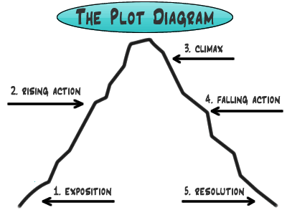

45. Point-of-view (pov): The identity of the narrative voice - the person or entity through whom/which the reader experiences the story. It is usually first-person or third-person. Point-of-view is a commonly misused term; it does not refer to the author’s or characters’ feelings, opinions, perspectives, biases, etc.
Point-of-view is the perspective from which the story is told. Depending on the perspective, we will know varying amounts of information about character’s minds and their perception of events and other characters.
There are three types of p-o-v:
a) First person: Uses “I” or “we“(a character in the story or a direct observer recounts the story) One character is telling the story from her/his perspective.
b) Second person: Uses “you” The author speaks directly to the reader. It is used in non-fiction.
c) Third person: Uses “he,” “she,” “it,” or “they” The author is telling about the characters.

There are three types of third person:

a) Limited omniscient: The author tells us the story through the thoughts and feelings of only one character. Animal Farm is told from the limited point-of-view of the common animals who are unaware of what is really happening as the pigs gradually and secretively take over the farm.

b) Omniscient: The author tells us everything about the story including the thoughts and feelings of all the characters, and even information in the author’s mind that no character knows.

c) Dramatic or Objective: We are only told what happens and what is said; we do not know any thoughts or feelings of the characters. It is called “dramatic” because it is similar to a play where, as an audience, we only know what we see and hear (we must guess what the thoughts of the characters are).

The unreliable narrator is a narrator who describes events in the story, but seems to make obvious mistakes or misinterpretations that may be apparent to a careful reader). Unreliable narration often serves to characterize the narrator as someone foolish, unobservant, naïve, innocent or deceptive.

46. Protagonist: The protagonist in a work of fiction is the character with whom the reader is meant to be chiefly concerned; she or he is the main character, who, whether sympathetic or not, is the focus of the plot. A character facing a conflict in a story or poem that he/she must overcome. Often, the antagonist is creating the conflict though the antagonist may also be seen to be helping the protagonist by “pushing” them along. A work of narrative or drama may have more than one protagonist.
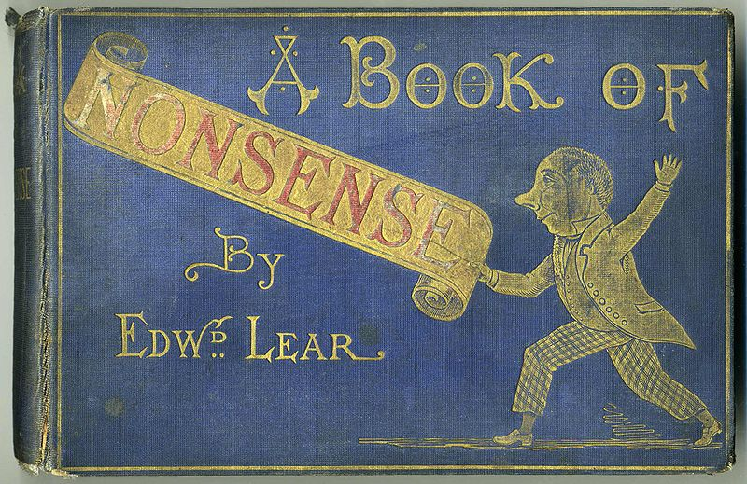

47. Satire*: An attack on or criticism of any stupidity or vice in the form of scathing humour, or an attack on what the author sees as dangerous religious, political, moral, or social standards. Satire became especially popular during the Enlightenment, in which it was believed that an artist could correct folly (stupidity) by using art as a mirror to reflect society. When people viewed the satire and saw their faults magnified in a distorted reflection, they could see how ridiculous their behaviour was and then correct it. That is the goal of satire even today. Popular cartoons such as The Simpsons and televised comedies like The Daily Show make use of it in modern media.
Ridicule, irony, exaggeration, and similar tools are almost always used in satire. Horatian satire tends to focus lightly on laughter and ridicule, but it maintains a playful tone. Generally, the tone is sympathetic and good humoured, somewhat tolerant of imperfection and folly even while expressing amusement at it. The name comes from the Roman poet Horace (65 BCE-8 CE), who preferred to ridicule human folly in general rather than condemn specific persons. In contrast, Juvenalian satire also uses withering invective (abusive or violent language used to attack, blame or denounce someone), insults, and a slashing attack. The name comes from the Roman poet Juvenal (60-140 CE), who frequently employed the device.

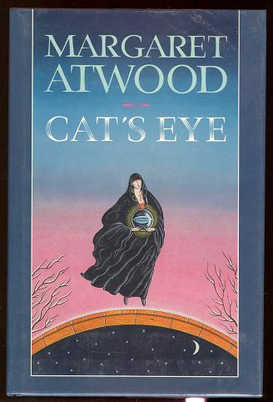

48. Setting: The general locale, historical time, and social circumstances in which the action of a fictional or dramatic work occurs; the setting of an episode or scene within a work is the particular physical location in which it takes place. Setting can be a central or peripheral factor in the meaning of a work. The setting is usually established through description--but sometimes narration or dialogue also reveals the location and time.

49. Simile*: An analogy or comparison implied by using an adverb such as like or as, in contrast with a metaphor which figuratively makes the comparison by stating outright that one thing is another thing. This figure of speech is of great antiquity. It is common in both prose and verse works. Robert Burns wrote:
O, my luve is like a red, red rose
That's newly sprung in June:
O, my luve is like the melodie
That's sweetly played in tune

50. SYMBOL*: A common object that has a deeper meaning is a symbol. A symbol is something that stands for something else. There are two kinds of symbols:
In contrast with an archetype (universal symbol), a private symbol is one to which an individual artist arbitrarily assigns a personal meaning. Private symbols may only be identifiable in the context of one specific story or poem. Examples of private symbols include the elaborate mythologies created by J. R. R. Tolkien in The Silmarillion (such as the One Ring as a symbol of power lust) or the Irish poet Yeats' use of a gyre [a circle or a spiral] to symbolize the cycles of history in the poem "The Second Coming."
A cultural symbol is widely or generally accepted as meaning something specific within an entire culture or social group, as opposed to a private symbol created by a single author that has meaning only within a single work or group of works. Examples of cultural symbols in Western culture include the cross as a symbol of Christianity, the gold ring as a symbol of marital commitment, and the color black as a symbol of mourning. Examples of cultural symbols in other cultures include white as a symbol of mourning in Japan and the Yin-Yang sphere as an oriental symbol of oppositional forces in balance. Any writer in a specific culture could use one of these symbols and be relatively confident that the reader would understand what each symbol represented.

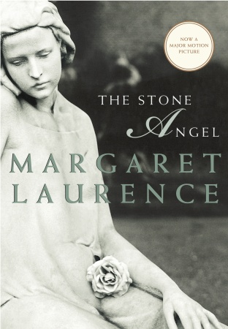
51. Synecdoche*: Using a part of an object representing the whole, or the whole of an object representing a part. For instance, a writer might state, "Twenty eyes watched our every move." Rather than implying that twenty disembodied eyes are swivelling to follow her as she walks by, she means that ten people watched the group's every move. When a captain calls out, "All hands on deck," he wants the whole sailors, not just their hands. This device is often used in journalism when it comes to reporting national or provincial news: “Ottawa will react to Russia’s actions in the Ukraine today.” The writer is using ‘Ottawa’ to represent the Canadian government.

52. Theme: A theme is the main idea or underlying meaning of a literary work. A theme may be stated outright or implied (hinted at). Theme differs from the subject or topic of a literary work because theme involves a statement or opinion about the topic. Themes may be major or minor. A major theme is an idea the author returns to time and again. It becomes one of the most important ideas in the story. Minor themes are ideas that may appear from time to time.
Usually we identify themes as consisting of two parts. There is a subject (such as love or prejudice) and the author’s view or comment on the subject (such as love is rare or any act of prejudice demeans all of us).
For example, the subject of a story might be war while the theme might be the idea that war is useless. Theme cannot be stated in one word. They are more complicated than that.

Four ways in which an author can express themes:

a) Themes are expressed and emphasized by the way the author makes us feel. Sharing the feelings of the main character, you also share the ideas that go through his mind.
b) Themes are presented in thoughts and conversations. Authors put words in their characters’ mouths only for good reasons. One of these is to emphasize a story’s themes. What a character says reveals what is on their mind. Look for thoughts that are repeated throughout the story.
c) Themes are suggested through the characters. The main character usually illustrates/reflects the most important theme of the story. A good way to get at this theme is to ask yourself the question, what does the main character learn in the story?
d) The actions or events in the story are used to develop theme. Characters naturally express ideas and feelings through their actions. One thing authors think about is what an action will say. In other words, how will the action express an idea or theme?

53. Tone/Voice*: The author’s attitude, stated (said outright) or implied (only hinted at), toward a subject. Tone reflects how the writer or author feels about their subject or listener. Possible attitudes include a pessimistic tone, optimistic tone, concerned tone, serious tone, bitter tone, humorous tone, defiant tone, regretful tone, and incredulous tone. An author’s tone is revealed through choice of words and details.

54. Unity*: The term applied to the effect of wholeness in a text which is achieved when there is a convincing relationship of part to parts, and parts to the whole, within the entire text.

*An asterisk beside a code and convention indicates that it also can be used in non-fiction writing.

